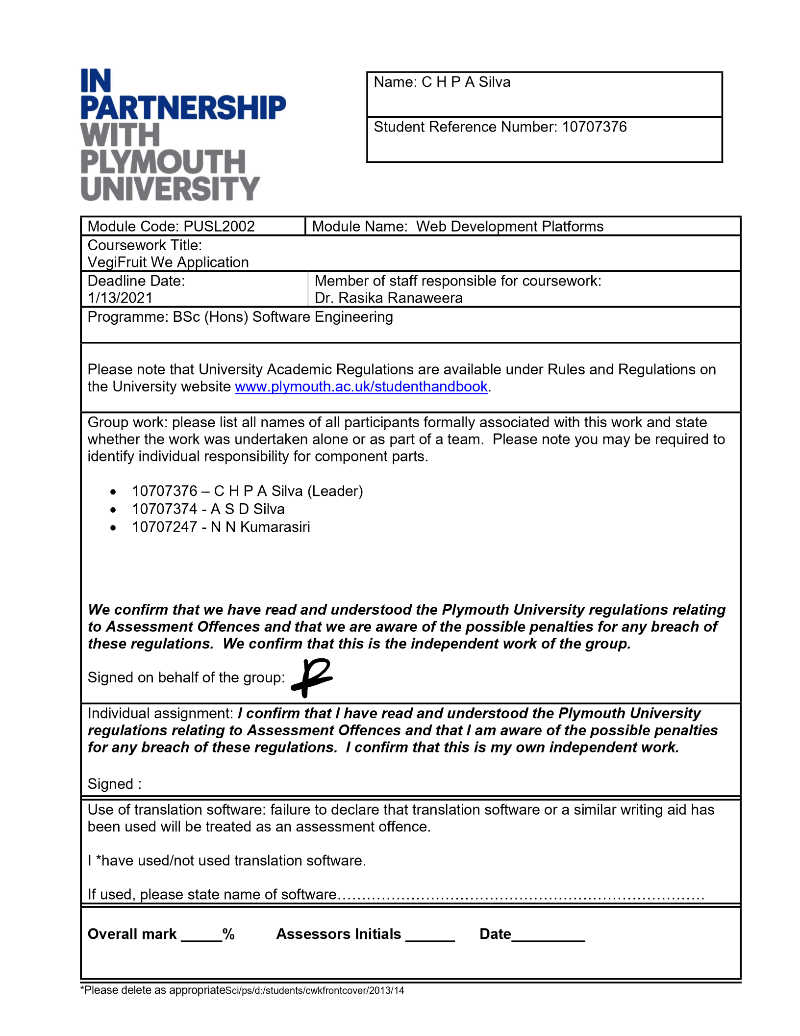

**Table of Contents**

01. INTRODUCTION 4

02.ACKNOWLEDGEMENT 5

04. SCREENSHOTS OF WEB APPLICATION 6

Farmer Dashboard 7

Farmer Profile 7

07. DISCUSSION 13

08. CONCLUSION 13

09.Work Load Matrix 13

# 01. INTRODUCTION

The task is to display the data on a map for farmers to sell their agrarian harvests with harvest details. The purchase is being made in collaboration with the Keels group and the Department of Agriculture, and the Keels group can purchase direct farmer’s products though this web application. This saves farmers time and labor and allows them to sell their produce quickly. Keels buys farmers’ produce and can all purchase to the Department of Agriculture. With this map a farmer can enter the weight of his/her produce, unit price, photographs of products etc., And also the farmers, DoA staff, Keels staff can view the reports and analytics of the products and transactions.

# 02.ACKNOWLEDGEMENT

We thank all those who devoted their energy, resources, and time to the success of this project. The foremost ultimate thank you goes to our determined and ever encouraging web development lecturer **Dr. Rasika Ranaweera.** No words can explain our gratitude for yourever-helping hand through this process. However, We can’t forget the support that both ourschool administrations and our families have granted us through this process. In conclusion, we will ever treasure the help from both mentioned and non-mentioned well-wishers deeply in his heart.

# 04. SCREENSHOTS OF WEB APPLICATION

## Login

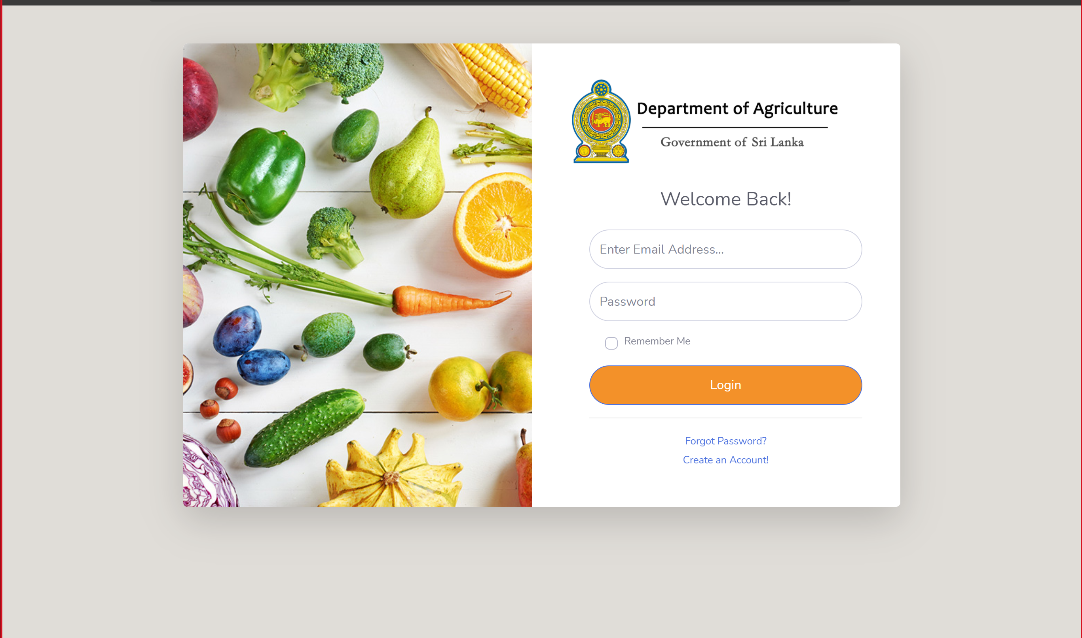

## Farmer Dashboard

# 

# Farmer Profile

# 

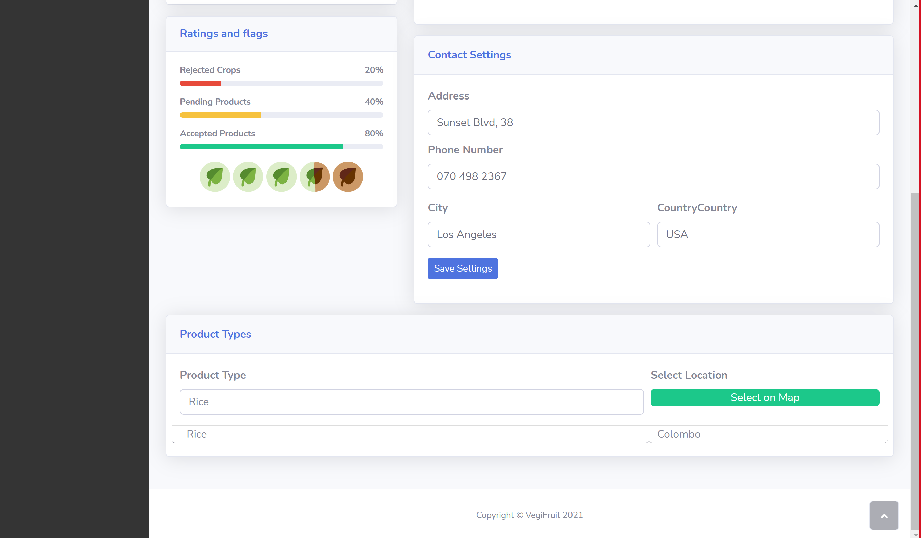

## Farmer Products

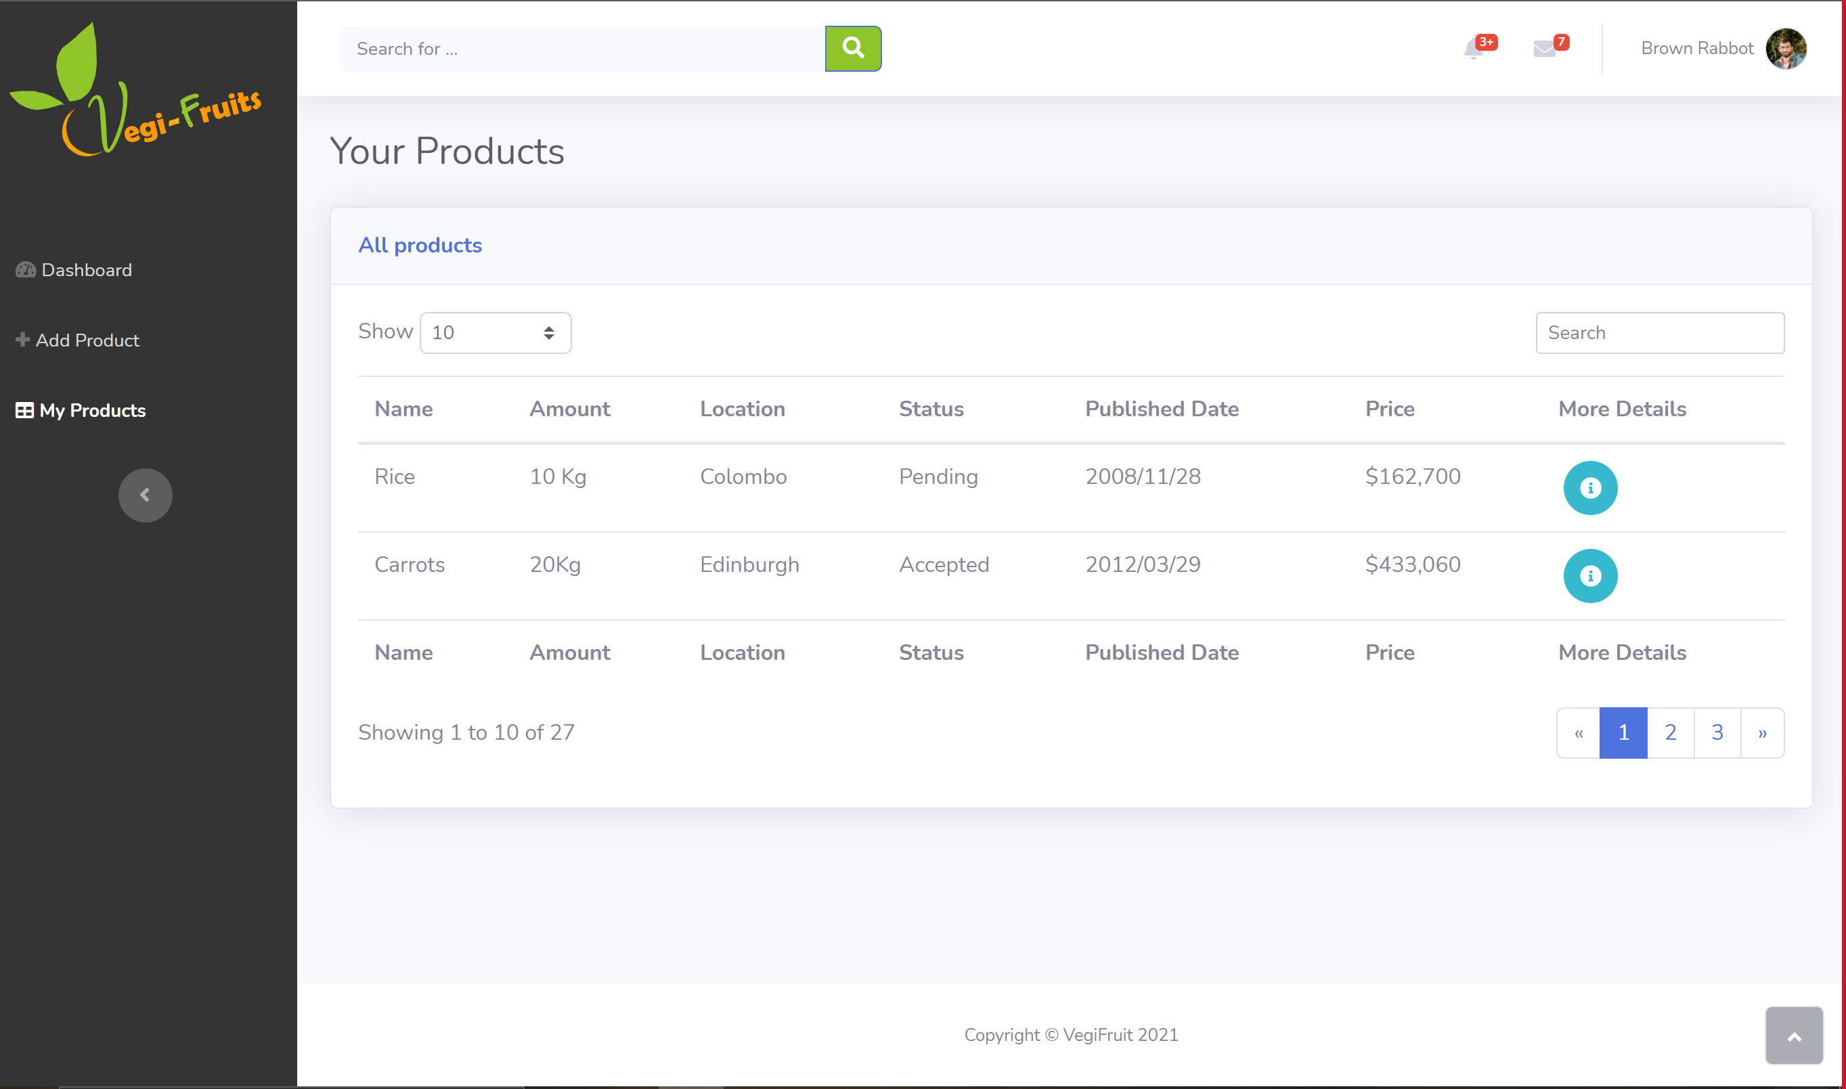

## Farmer Registration

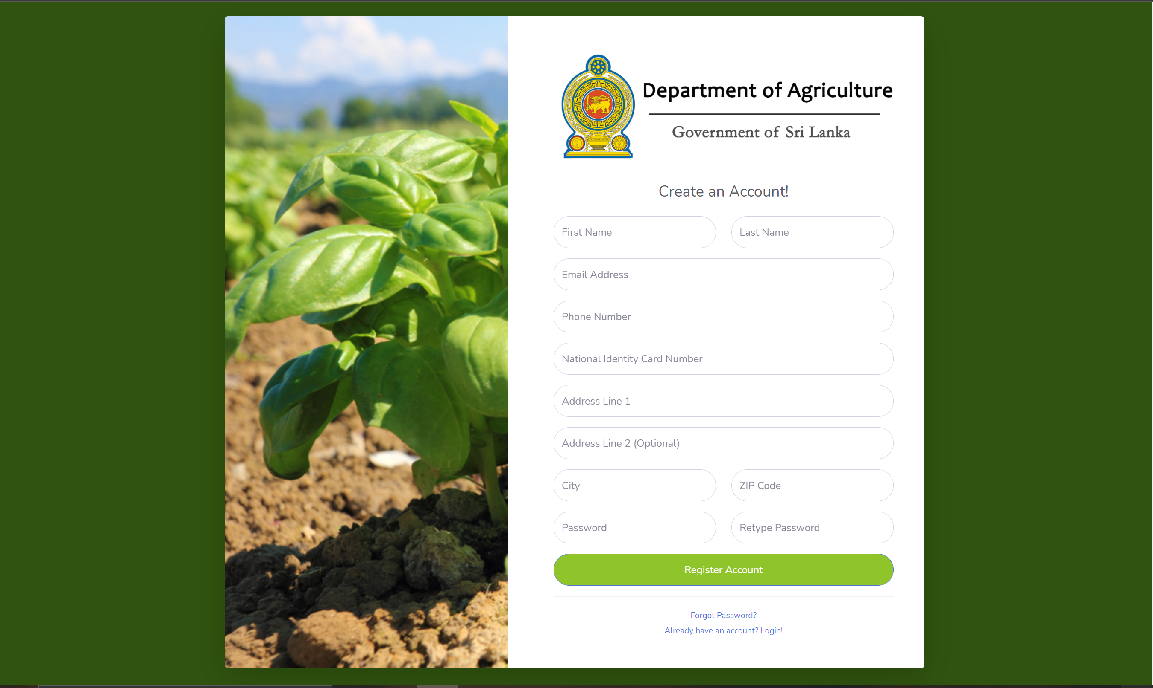

## Add Product – Farmer

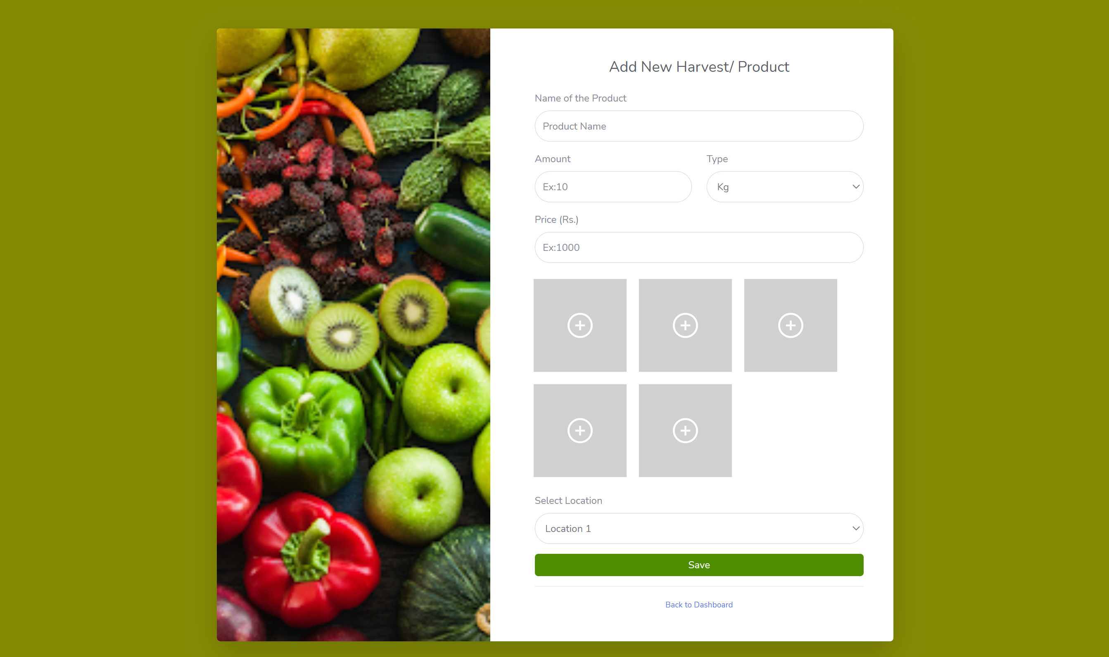

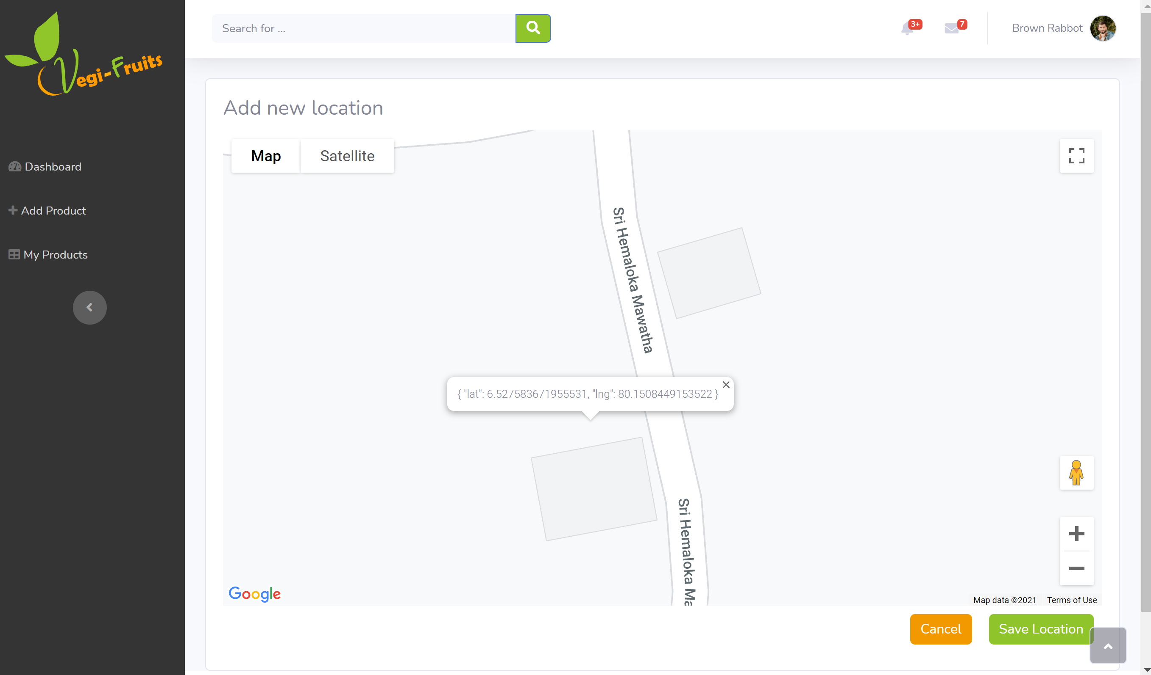

## Forgot Password

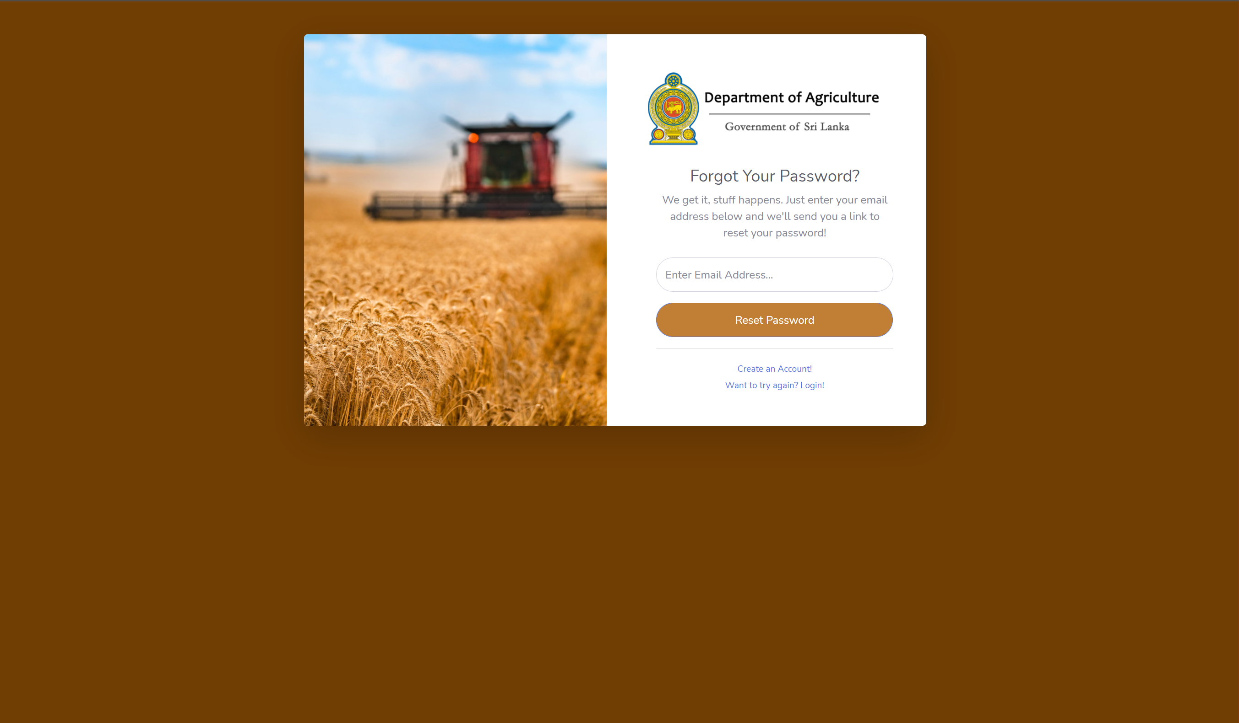

## Staff Dashboard

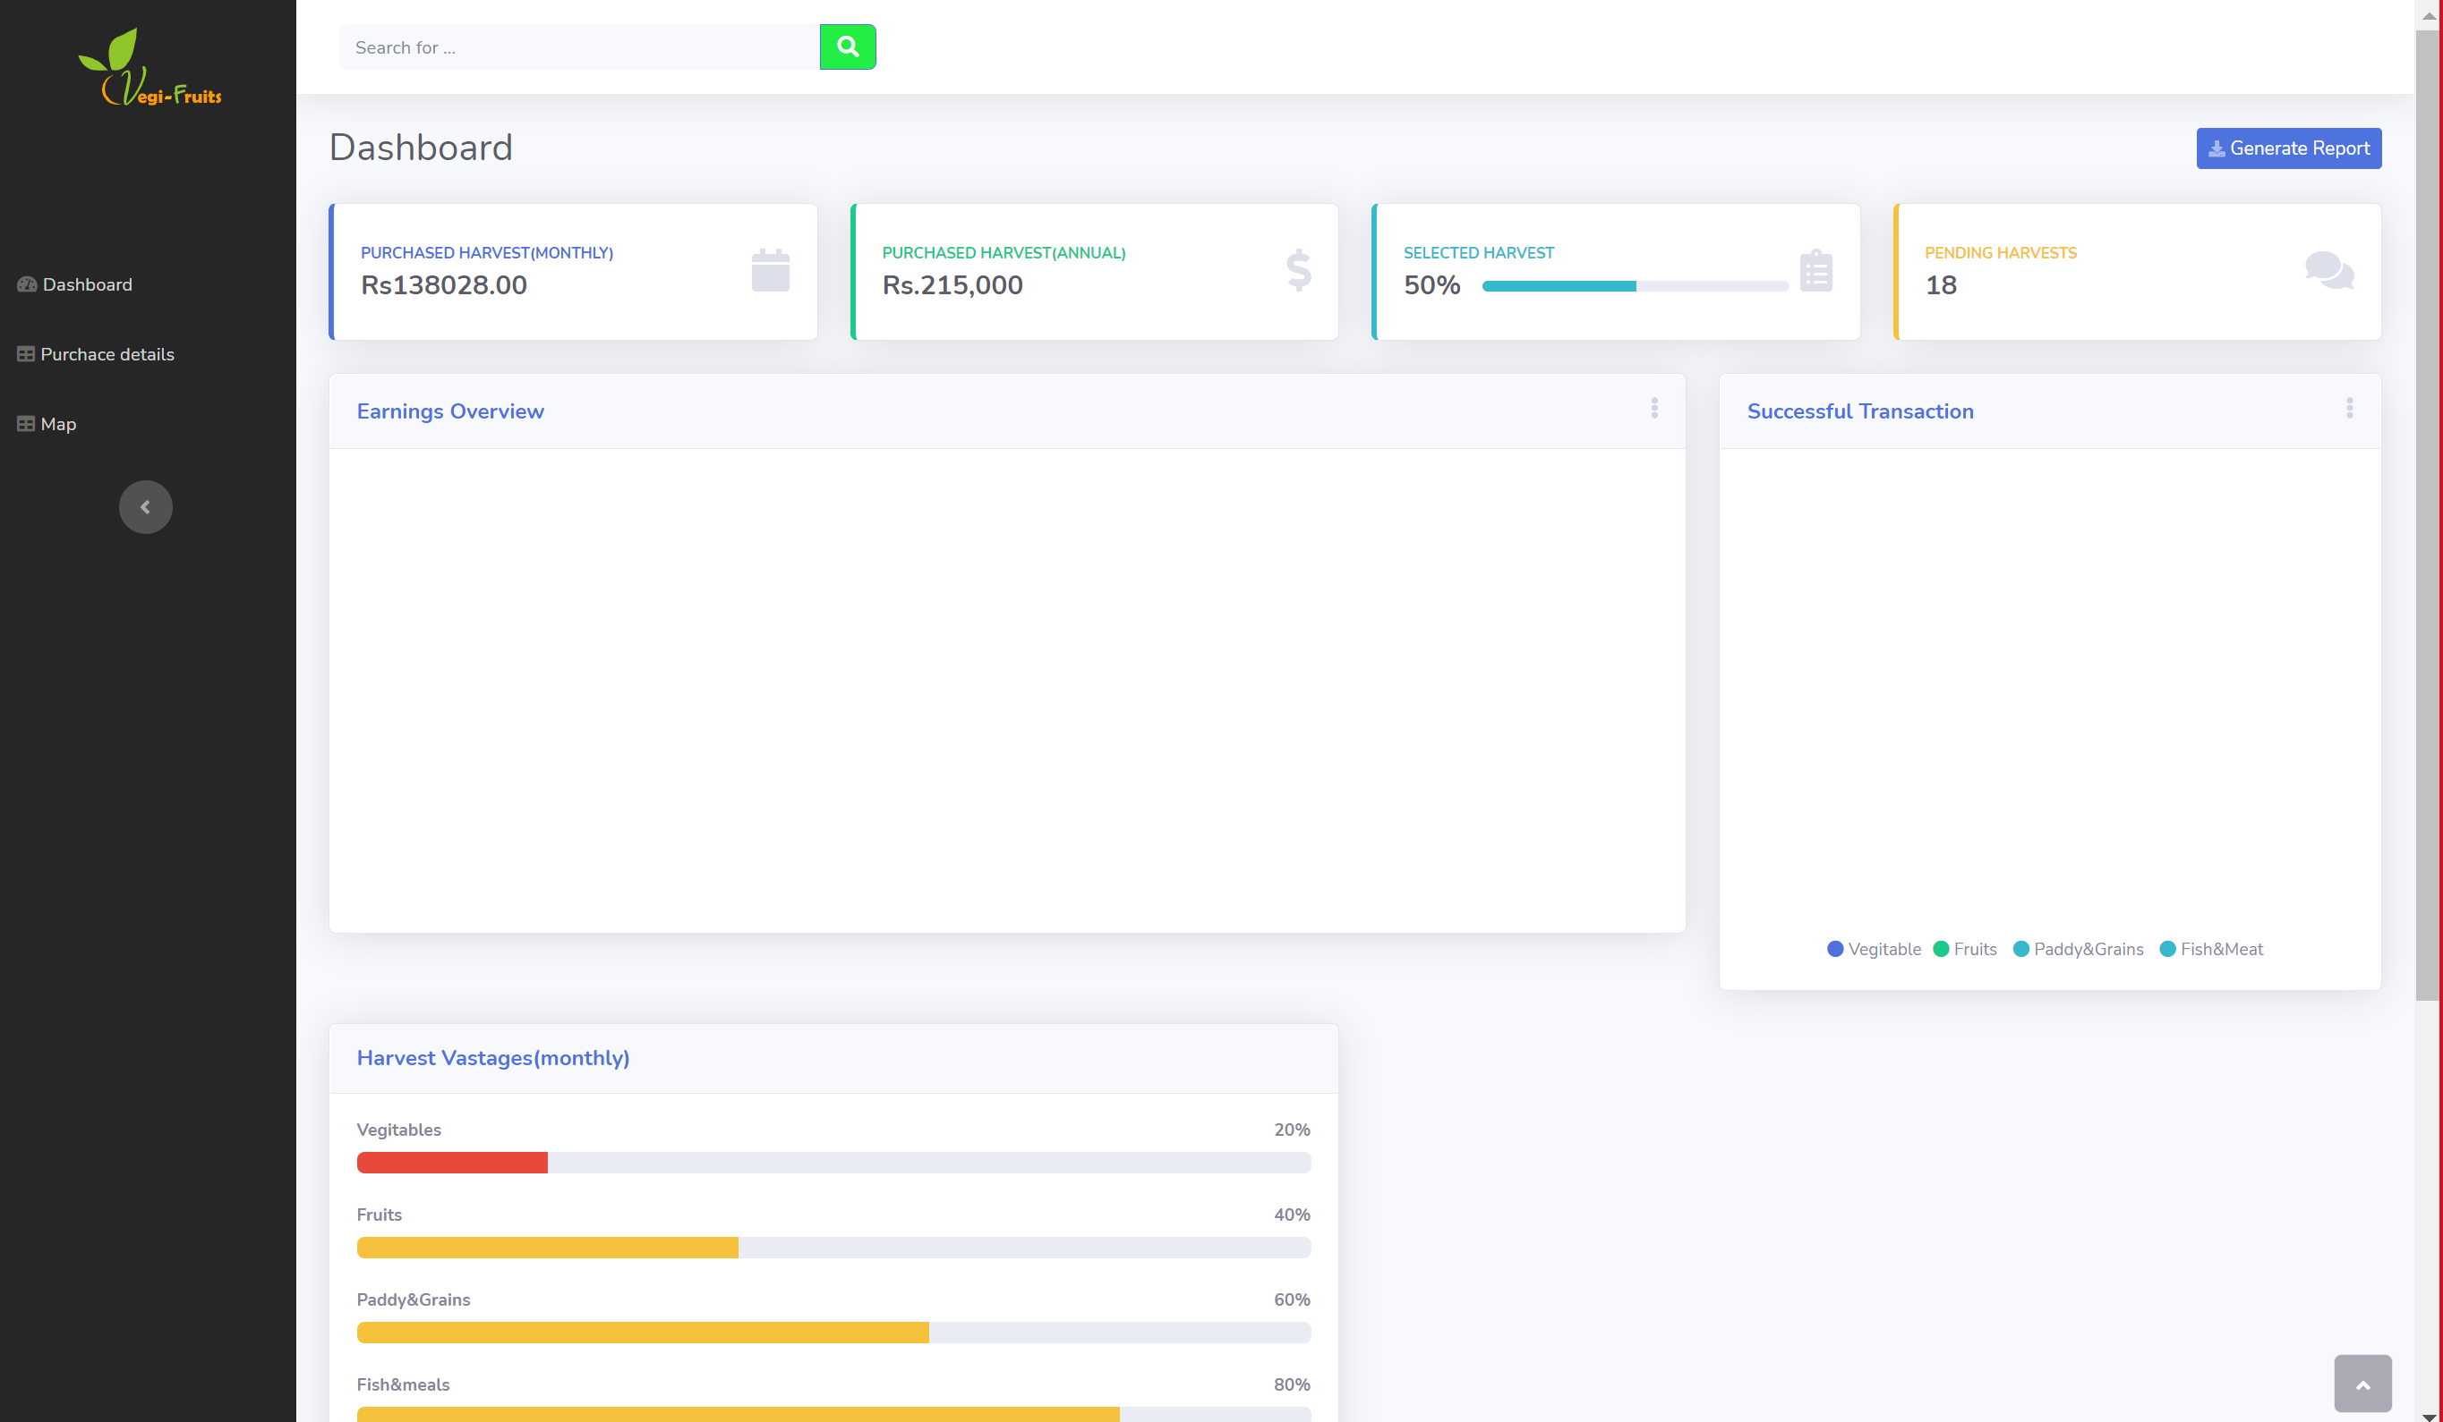

## Staff - Purchase details

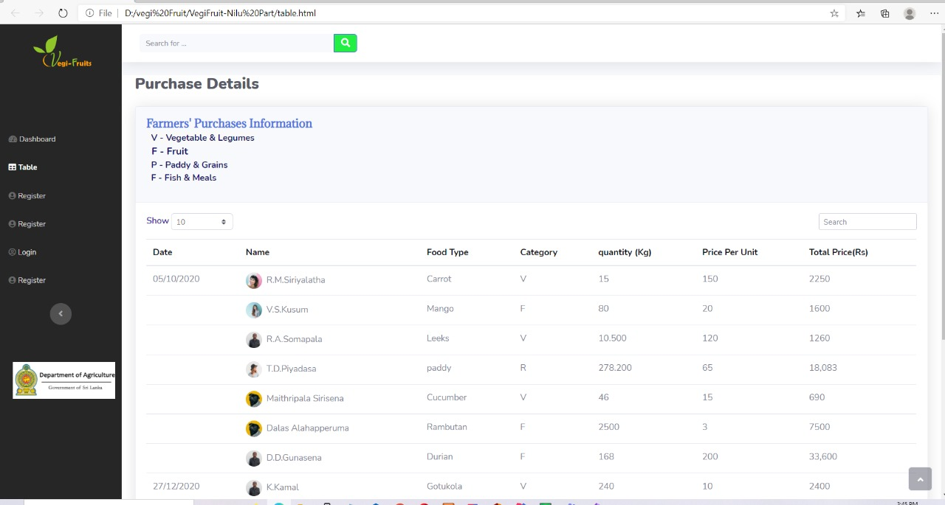

## Public home

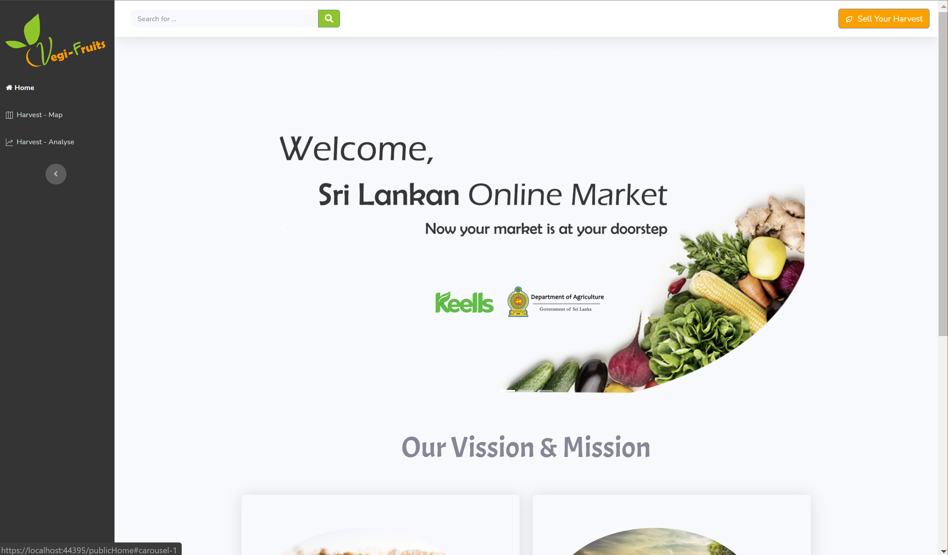

## Harvest map

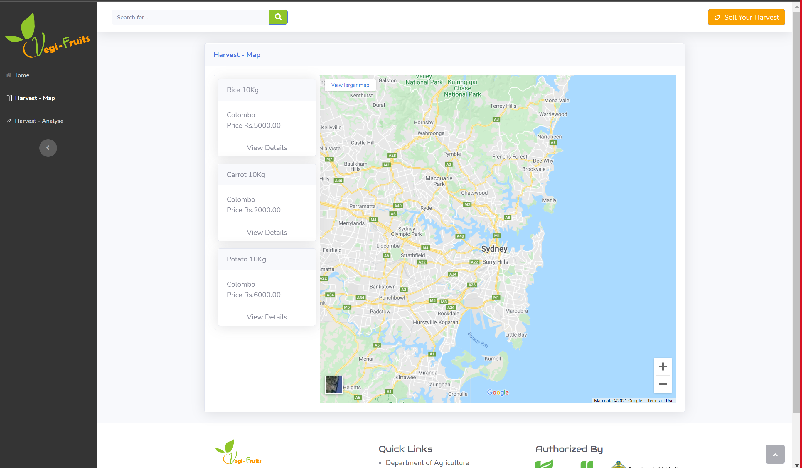

## **07. DISCUSSION**

This application’s not easier to process make to our group because it happens to various code errors while we are coding this application. The error we faced to Connect to the database and when using the google map. Until the last minute, we tried to fix the bugs we had faced.. To overcome this error situation, we get help from our seniors after discussing with our group members.

## 

## 08. CONCLUSION

We created a system for the Keels and Department of agriculture which can be used to easily manage the farmers products that keels can buy with few clicks using the website. Also this website can save their time and wastage with this website. With the help of the google map facilities, the keels staff can see where are the crops located, When those are published.

## 09.Work Load Matrix

|  |  |  |  |
| --- | --- | --- | --- |
| Member  Activity | Member 01 ID: 10707376 | Member 02 ID: 10707374 | Member 03 ID: 10707247 |
| Login | R | S | S |
| Farmer System | R | S | S |
| Keels & Public System | S | R | S |
| DoA System | S | S | R |
| Report | R | R | R |
| Total Contribution- (100%) | 40% | 30% | 30% |